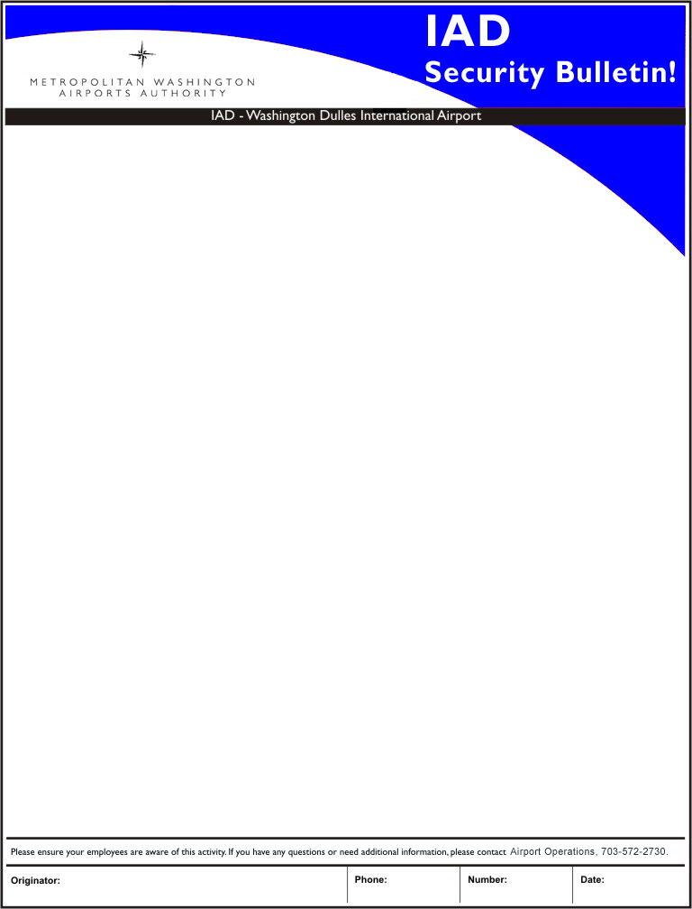

February 2, 2010

Effective March 1, 2010, the Criminal History Record Check
(CHRC) fee will be changed.

An $11 fee will be imposed on all NEW BADGE APPLICANTS. This fee reflects the cost imposed upon the Airports Authority for conducting the Transportation Security Administration’s Security Threat Assessment (TSA STA) portion the background check. Additionally, this fee will be imposed on transferred employees and “Self Reporting” Domestic Air Carriers. Please see the chart of fees below for further clarification:

NEW BADGE APPLICANTS
(first time badge holders, and those with a break in service over 30 days)

Most Employees (Foreign Air Carriers, Concessions, Contractors, etc.)
Fingerprint-based CHRC $27
TSA STA $11 (Increase from Jan. 4)
Total $38

Domestic Air Carrier Employees (Transferred Employees, Self Reporting)
TSA STA $11 (New Fee)

There will be NO renewal fees or charges to current badge holders.

Federal, State, and local government employees (to include MWAA personnel) are exempt of these fees.

Larry Gosnell, ASC | 703-572-2730 | 020210 | 2/2/2010

